|  |  |  |
| --- | --- | --- |
| S.No | Title | Libraries |
|  | Scientific Computing Libraries | Pandas |
| NumPy |
| SCI-PY |
|  | Visualisation Libraries | Matplotlib |
| Seaborn |
|  | Algorithmic Libraries | SCIKIT – LEARN |
| STATS MODELS |

* File Formats

( csv , .json , .hdf , .xlsx,…..)

* File Path

( C:/Desktop/My Files/ mydata.csv )

* Download data from Website

1. Kaggle
2. Data.gov
3. Google Cloud Public Datasets

**Data Normalization**

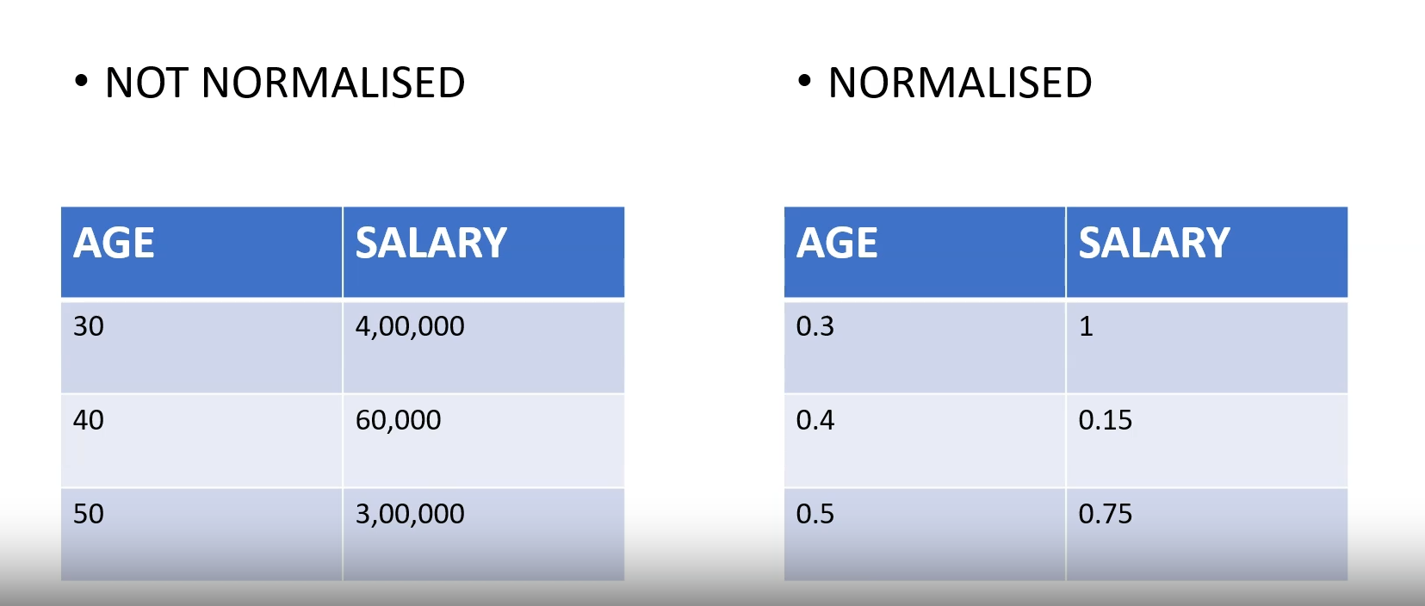

**Binning**

It just groups the values into bins and also it convert the numerical value into categorical data. And Vice Versa Also

